ME 424 Engineering Design VIII

Phase 6 – Final Evaluation

**3D Printed Granular Jamming Hand**

**A Senior Report**

**Group #9:**

Melissa Indoe

Chris Kang

Sean Phelan

Maggie Serra

Chris Wallace

**Advisors:**

Robert Chang

Jennifer Field

**STEVENS INSTITUTE OF TECHNOLOGY**

Castle Point On Hudson

Hoboken NJ 07030

(May 2014)

**3D Printed Granular Jamming Hand**

# Abstract

An open-source and primarily 3D printable hand prosthesis has been developed by a team of five Mechanical Engineering seniors in a student-driven design project. The hand performs relatively low strength, high dexterity everyday tasks. The hand prosthesis combines the technologies of existing 3D printed hands with the use of granular jamming to maintain a firm grip at a fraction of the cost of existing prostheses. Conceptual designs have been generated, analyzed, and finalized. A hand prototype has been fabricated. The files have been uploaded to an easily accessible location for all to use, and a set of assembly and use instructions have been created for end-users to follow.

**Authors:** Melissa Indoe, Chris Kang, Sean Phelan, Maggie Serra, and Chris Wallace

**Advisors:** Robert Chang and Jennifer Field

**Department:** The Department of Mechanical Engineering

Contents

Abstract 2

Introduction 4

Project Objective 4

Semester Goals 4

Deliverables 4

Device Design 5

Hand Design 5

Forearm Design 8

Servo Hub Design 10

Granular Jamming Pad 12

Electronics and Programming 14

Prototype Fabrication 16

Performance Testing 18

Potential Improvements 20

Panel Comments 21

Gantt Chart 23

Budget 24

Team Budget 24

Actual Budget 25

Website 26

Team Website 26

Github Page 27

# Introduction

## Project Objective

The objective of the 3D printed granular jamming hand project is to develop a prototype hand and forearm prosthesis that can be used as either directly as a prosthetic device or as a development platform for ongoing research and improvement. The hand is open-source and all source files are freely available on github, meaning that anyone with knowledge of the project is able to download these files and make one themselves. The hand is designed to be an easily approachable project with low barrier to entry, so that a novice with no previous design, 3D printing, or assembly experience can easily manufacture and assemble one. Instructions for manufacture and assembly are actually bundled along with the parts files, Arduino code, etc.

The overarching goal of all this is to make the hand readily available as an extremely low cost prosthetic (since existing prosthetics cost in excess of $11,000, and the hand actually tops out at about $360). In this way, anyone with 3D printer access would be able to make prosthetics. Humanitarian aid groups, with only a hobby 3D printer (costing around $2,000) would be able to travel to impoverished areas and individually customize and manufacture prosthetics within about 2 days. The design has large tolerances and is meant to be very forgiving, so even if the print is sub-par or if the part warps off the print bed, the finished hand will still generally function normally. Groups would be able to use untrained volunteer labor, since the hand is designed around ease of assembly (with assembly taking about an hour at most), and beyond the 3D printer, a set of screwdrivers, and a bottle of ABS cement, groups would need no tools for assembly. This extremely simple and stripped-down design allows a small group of untrained individuals with a very small initial investment make a huge difference in people’s lives.

The goals for the hand itself are for it to be fairly high-functioning and task-oriented, meaning that it should be able to perform many household tasks requiring fairly low strength and high dexterity (i.e. opening doors, manipulating occupational therapy cutlery, etc). If the hand is able to complete most of these tasks, it would be extremely useful in day-to-day life, granting independence to amputees worldwide.

## Semester Goals

The primary goal for this semester is to have a finished prototype of the prosthesis, as well as updating our team’s github with all relevant design information. There is a secondary goal of maintaining a team website acting as more of a “front end”, discussing the project and linking to the information available on github. This website is a way to get the project out there, so that it can be seen by individuals who might be interested in it or who could benefit from it.

## Deliverables

Year-end deliverables include a completed prototype of the device, itself comprising the hand, a granular jamming pad in the palm, and the forearm fully equipped with all electronics and Arduino programs. In addition to these physical deliverables, the team wanted to make the project readily available to others who desire to use or further develop the device. To accommodate this, the team has developed a website with device information and download links to the model files, Arduino code, and instructions on how to manufacture and assemble the device.

Now that the year is over, the team is very happy to announce that all deliverables have been fully realized. The device has been manufactured and assembled with the hand, granular jamming pad, forearm housing, electronics and programming all completed. The team has made a website with links to all the downloadable files and instructions on how to manufacture and assemble the device.

During phase 5, the hand was redesigned with the thumb mounted in opposition to the middle finger, facilitating grip of small objects. The wire guides were also redesigned twice, firstly to facilitate ease of printing and secondly for ease of assembly. The forearm model was developed and finalized, the sensor setup was totally revamped, and the granular jamming pad production was revisited as well.

In phase 6, the forearm was printed and assembled, servo hubs were made, the entire hand and forearm assembly was put together, and a demo program showing hand functionality was created. Currently, all design is complete and testing is well underway. A poster has been put together for Senior Design day, held on April 30th, and a final presentation is being prepared, and will be given on Thursday, May 8th. The website is also in the process of being updated, and will be totally finalized by presentation day.

# Device Design

The 3D printed granular jamming hand is designed around ease of use. Every aspect of the design keeps the end user in mind, carefully considering aspects of durability, assembly, versatility, and safety. Since it is meant to be interfacing directly with people, the hand includes built-in compliance in the form of the rubber bands straightening the fingers, and springs on the cables pulling them in. Since it must be dexterous, it has three individually driven fingers (and two on a combined drive), allowing for a large number of different types of grips. Since it must be able to do many tasks, it has a granular jamming pad on the palm, helping it manipulate very small or awkwardly shaped items, adding in some of the functionality lost by simplifying the design of the fingers (doing away with adduction and abduction). The device is durable, with most elements able to survive the average prosthetic lifetime (for traditional prosthetics) of 3-4 years, and those that aren’t (coffee grounds, small rubber bands) chosen for their ease of replacement. It is also very easy to assemble, with the hand itself printed as a non-assembly model, and the arm consisting of about eight 3D printed pieces. A more detailed assessment of current design and the design process can be seen below.

## Hand Design

Finger design was finalized during phase 4. During this phase, the joint pins were changed from a cylindrical design to a conical one, reducing the overhangs occurring from printing a flat face over air. Instead of printing in one layer over air, the conical pins “step” upward at a 22 degree angle relative to the printer bed. By doing this, overhangs are drastically decreased, improving the quality of the pin interface and preventing bridging. Additionally, the cable guides were redesigned from a series of round horizontal pins to a reduced number of flat faces with round holes. This removed overhangs and made threading the cable that moves the finger a much more intuitive process. Rather than winding cable over, under, or around pins, it is now just threaded through one hole, which is much simpler for the assembler.

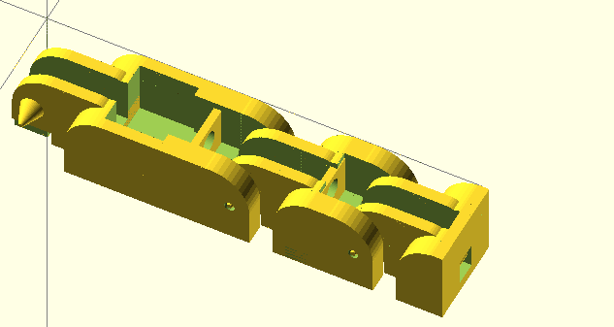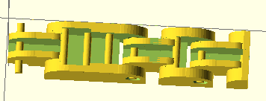

Figure 1: Before and after of finger design at the conclusion of phase 4, demonstrating modified joint pins and cable guides.

The overall hand design was finalized during phases 5 and 6. During phase 5, the thumb was moved to a position where it was mounted in opposition to the middle finger. This was because the hand design was simplified and did not include an analog for the thenar eminence, the muscle group that allows the thumb to oppose finger motion. Adding in this “muscle group” in the form of a fifth servo motor was deemed too complex of a solution. Adding another servo would require a complete redesign of the forearm as there was no way to fit it within the existing design, would require design of an entirely new type of non-assembly 3D printable hinge since the existing hinge types used in the fingers would not work in that context, and would require that two motors be used on just one digit (the thumb) adding complexity to the design with very little benefit.

Simply moving the attachement point of the thumb allowed the middle finger and thumb to meet, allowing for realistic grip of small-to-medium-sized objects. This also placed the thumb in a position where it stabilized the grip of the other fingers, necessary for the grips used to open doors, pick up cups, etc. This design appears less realistic in its resting position than the previous design, but the new thumb placement is necessary for much of hand functionality.

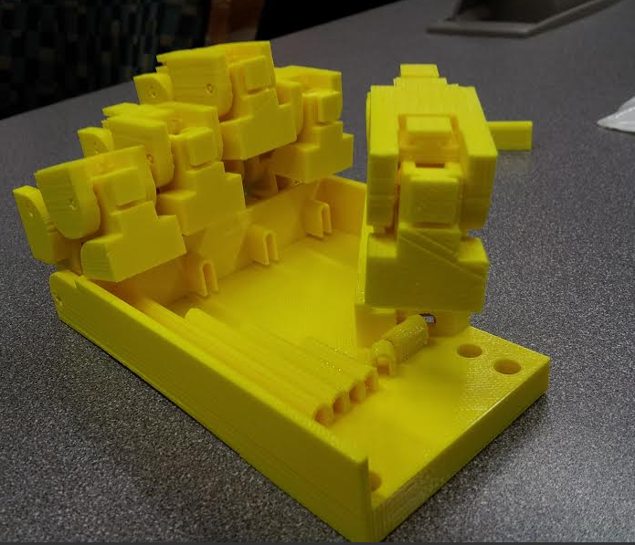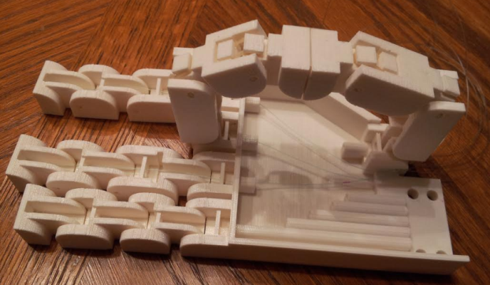

Figure 2: Phase 4 (left) and phase 5 (right) hand designs, showing the difference in thumb motion.

During phase 6 the palm cable guides were redesigned and support was added for set screws. The cable guide redesign was done for three reasons: firstly to make them intuitive and simple to cable, secondly to create more space for the granular jamming pad, and thirdly to allow for removal of support material, in case the printer utilized by the end user has support material enabled. The guides went through two major redesigns. At first they were tall (equal to the height of the palm) rounded rectangles. During the first redesign this was changed to a short (half as tall as the palm) post-with-hole design, in order to make threading the wire guides simpler and make more space for the granular jamming pad, by taking up less of the depth of the palm.



Figure 3: First (left) and second (right) cable guide cross section designs.

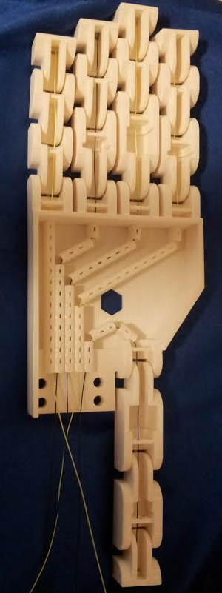This first redesign lead to some issues with the support material removal process. Since the cross-section of the cable guide hole was so small, the acid bath was only allowed a very small contact area and it took a very long time (to the order of what would probably be a few days or weeks) for the support material removal process. As a result the cable guides were redesigned again with wider holes, again taking on a rounded rectangle shape, and incorporating holes on the surface so that the acid bath could access the support material from multiple angles. This design ended up being used in the final version of the hand.

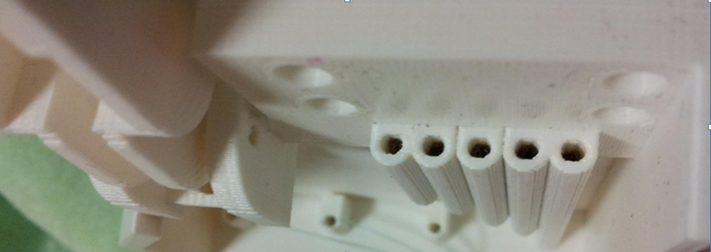

Figure 4: Post-with-hole cable guide design is blocked by black support material (top). Final hand design demonstrates rounded rectangle cable guides with regularly spaced holes to allow access by acid (bottom).

The final design changes, also made during phase 6, were to add a few more sections of cable guide improving the leverage angle for the thumb, adding holes for set screws, and to include a hexagonal hole for the fitting of the granular jamming pad, allowing the pad to be attached via an L-fitting protruding from the back of the hand. This meant that there would always be one element keeping the pad in place, even as the glue holding the pad to the sides of the hand begins to fatigue.

The set screw support was added so that set screws could be incorporated into the hand. It consisted of holes at each joint interface, each accommodating one 6/32 by 1/8 set screw. This support was added to prevent hyperflexation of the fingers, which would cause a small amount of static friction that the motors had to overcome before the hand would begin moving. This increases fluidity of motion and slightly decreases the force that must be exerted by the motors. The set screws are an optional addition (as the hand works normally without them), but with them it appears more smooth and lifelike.

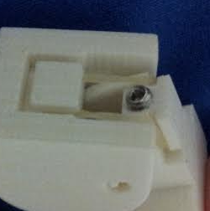

Figure 5: Demonstration of joint interface with set screw.

## Forearm Design

The design of the forearm plays an important role because it houses all the necessary electronics for gripping and jamming, provides protection of sensitive components from outside elements, and guides the cables for hand motion, all while maintaining the outer appearance of a human forearm. The team originally wanted to utilize a pre-existing open-source forearm, the InMoov forearm, but it was impossible to modify the parts files due to the limited feature recognition features available in SolidWorks (the parts files had been made available as .stl files—not directly editable in SolidWorks, and the built-in feature recognition created errors in the geometry). Therefore the forearm housing and forearm mounts were all created from scratch within the SolidWorks environment.

The most important parts of the forearm are the sensor and motor mounts. The purpose of this mount design is to connect the sensors and motors together, so that rotary motor motion of the motor can directly translate to the linear motion of a potentiometer. In this way the potentiometer can be used to track finger motion, and, if it stops moving, detect collision.

The way that the motor mounts work is that fishing line is fed through a hole on the mount, wraps around the potentiometer, and attaches to the servo hub. The mount hole helps keep the fishing line for each motor line separated from fishing line segments running other fingers, preventing tangles. More importantly, it lines up the fishing line with the mount point on the linear potentiometer so that it will exert forces in the x-direction only, without generating downward force by getting pulled upward by the sensor mount. Avoiding this was important because it could impede sensor motion. Finally the face adds a mounting point for a spring. As of the time of the report-writing there are not currently springs in the forearm, but they will likely be added between mount and potentiometer before the oral presentation. These springs, while not totally necessary for functionality, will add some compliance to the system, and additionally, by using springs with a known K value, force exerted can actually be determined via linear potentiometer values rather than just binary not touching/touching feedback.

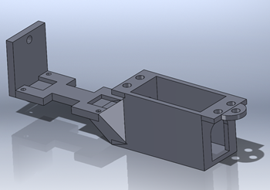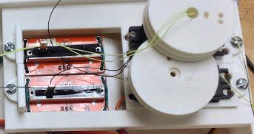

Figure 6: Sensor and motor mount model (left) and two printed and assembled sensor and motor mounts (right).

The flat face is a potentiometer mount. It includes holes for mounting as well as insets along the sides to accommodate the pins. The insets are symmetrical, even though the pins are only on one side, so that the potentiometers can be oriented forwards or backwards as needed to fit inside the forearm. The small depressions at either end are to accommodate the solder points on the back of the board. The team didn’t want to crush the solder points by pressing them into the mounting board and added these small depressions to avoid this. The motor mount consists of a box to drop the motor into and holes for the motor screws. It has holes to accommodate wires on both sides so that motors can be dropped in either forwards or backwards in order to stagger the position of the motor hubs. Finally, mounting points were added at the front and back of the motor and sensor mounts in order to attach them to the forearm. 3D printing was successfully implemented for mount creation, and four of these mounts were manufactured.

The next element of forearm development was the forearm housing. A top and bottom housing assembly were both generated. The bottom housing assembly was printed in two pieces and included attachment points for all four of the motor and sensor mounts, as well as the mounting point for the hand. The top housing was also printed in two pieces and included a mount for the Arduino. The reason why the forearm halves were each printed in two pieces is because the print area of most printers available is about 10x10x10 inches. The forearm, however, is about 12 inches at its longest point. Therefore the forearm halves were split into two pieces to better accommodate the available printer build area.

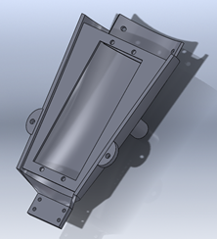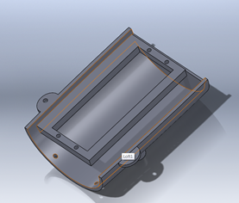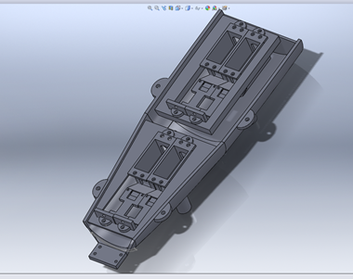

**Figure 7: Bottom half pieces (left, middle) and bottom half assembly (right)**

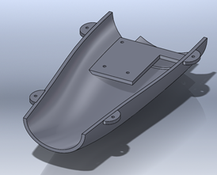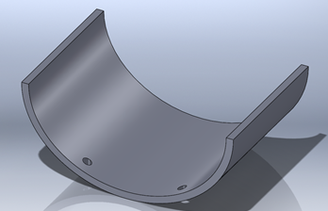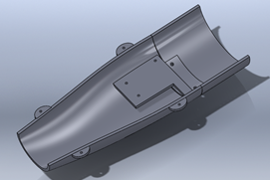

**Figure 8: Top half pieces (left, middle) and top half assembly (right)**

Another aspect considered in forearm design was the tolerance of the 3D printer. In order to determine the size of mounts, exact parts dimensions were measured with calipers. When making the CAD model, a tolerance value had to be added in. Since 3D printing tends to add a little extra material, making holes the exact size of the servos, sensors, etc in the forearm model would actually lead to those holes being slightly too small coming off the printer. Therefore an extra 0.02 inches were added in every dimension to accommodate this distortion.

The forearm design as it stands can contain the linear potentiometer sensors, servo motors, and the Arduino. Initial intent of making the forearm was to contain every part of the prosthetic inside the forearm. Currently however there are not mounts for the solenoid and pump. This is for two reasons. Firstly, the solenoid and pump themselves have no mounting holes, faces, or any other designed mounting points, making them extremely difficult to design mounts for. Secondly, the current sensor and motor mounts fill most of the volume inside the forearm as it is. The next improvement will be to order smaller parts, possibly move the motor and sensor mounts closer together, and to design mounts for the pump and solenoid.

## Servo Hub Design

The servo hubs are one of the more interesting parts of the forearm assembly. The servos have about a 180 degree turning radius, and lose accuracy at the edges of their rotation. Therefore they have about 160 usable degrees of rotation (removing 10 degrees from either end). The servo hubs were designed by first measuring the length of fishing line that had to be pulled in for complete motion of one finger, and then translating that value to the circumference of a circle (after accounting for the fact that only 160 degrees of that circle would be usable by the motor). By doing this and then adding in an extra safety factor, the team could determine what size the servo hubs needed to be. Since there was a significant amount of horizontal overlap inside the forearm, the hubs then had to be staggered in height so they could fit under or over each other rather than colliding. A tunnel was added so that fishing line could be fed in at the center of the hub, halfway between the two flanges, and tied off at the top. This would prevent fishing line from rolling off the top or bottom of the hub. Finally, a double-hub was made for the ring and pinky fingers, since both fingers were to be controlled by the same motor.

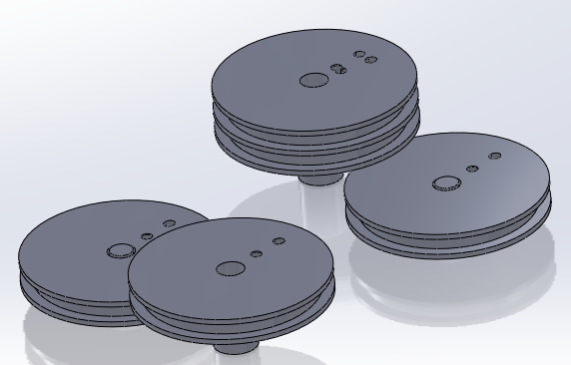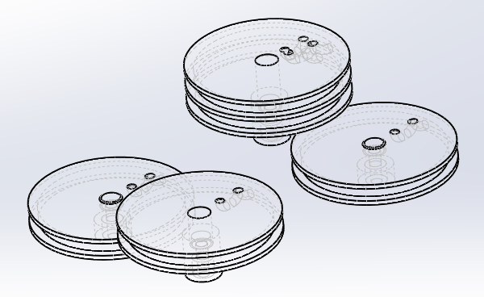

Figure 9: Solidworks model of servo hubs showing staggered heights. Left shows solid model of servo hubs. Right shows wireframe model of servo hubs, demonstrating tunnels for fishing line.

However, the construction and design of the servo hubs is not what makes them a particularly interesting forearm element. What does is the novel way that they are attached to the servos themselves. The servo motors all have a metal gear meant to fit into the hub selection that they come with. These hubs are injection molded with teeth fitting the gear of the motor. Using these hubs for the forearm would be impossible, however, because of the requirement for staggered heights. Therefore, it became necessary to create meshing teeth on our own servo hubs. 3D printing these teeth would be very difficult due to the tolerances involved, which may not even be possible on some hobby printers. Additionally, making it necessary to use specialized tools to cut out teeth would make the project difficult for the layperson to put together.

The solution to this was extremely simple and clever. There exists ABS cement, which is meant to work as glue between two pieces of ABS (usually piping, etc). It is a suspension of ABS in a solvent, generally acetone. When it comes into contact with ABS plastic, it actually melts the plastic, and once the acetone evaporates, solidifies into a chemical weld between two ABS pieces. It is a very inexpensive and readily available material, costing about $3 a can. The solution to the problem of toothed hubs was to print the servo hubs with holes slightly smaller than the servo gears. A small amount of ABS cement was dripped into these holes, and then the now-tacky servo hubs were pressed onto the servo gears. This molded gear teeth into the walls of the servo hubs, and after just a few minutes of drying time, the hubs were completely solidified with gear teeth perfectly matching those of the servo. In this way, a simple and novel solution was found for what would otherwise be a very complex problem.

## Granular Jamming Pad

The 3D printed granular jamming hand also utilizes the concept of granular jamming. In this process, small particles in a flexible container act as a fluid when loosely packed, but become rigid when the granules are tightly packed together. Applying granular jamming to the hand makes it capable of picking up relatively small objects which would otherwise be difficult for the fingers, which have fairly low dexterity, to manipulate. Picking up objects is done by pressing the pad on the object, jamming the granules by using a vacuum to remove air from the pad, and then lifting the pad, which will carry the now-enveloped object.

The team previously found via research that a pressure difference of 75 kPa was sufficient to pick up objects, and purchased a small medical pump with this specification. They also found that inflating the granular jamming pad to slightly above atmospheric pressure would aid in the liquid phase of the granular jamming, making it much easier for the pad to initially wrap around objects. To this end, they decided on a pump setup where the solenoid, rather than venting to air to release vacuum, actually is attached to the exhaust of the pump. This way the pump exhaust can add a small amount of air to the pad and get it to above atmospheric pressure, ideal for granular jamming.

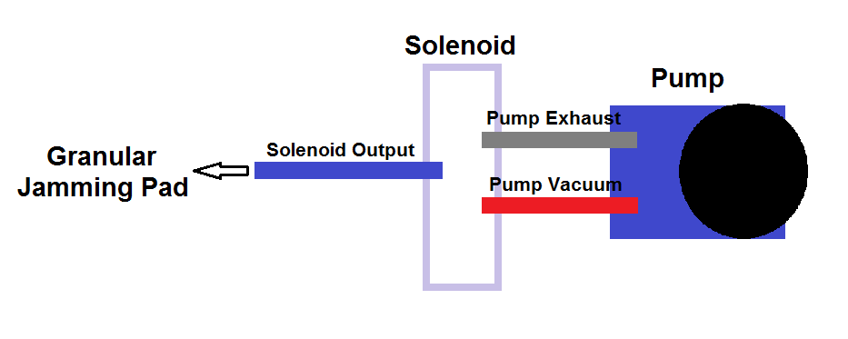

Figure 10: Diagram of pump, valve and pad setup.

It was decided that the pump would be controlled by manually starting and stopping when a switch is pressed on the forearm, to keep programming within the scope of the project. Since this prototype is only a proof of concept, the team has decided to control the pump using a push-button. Ultimately, it may be controlled via Bluetooth commands but this functionality has not been created by the team for the prototype.

The materials used for the granular jamming applications are coffee grounds (determined via research to be the most effective granular jamming material), a kitchen sponge acting as a filter between vacuum and coffee grounds, and an ordinary reusable kitchen glove for the housing. Originally, disposable latex gloves were to be used; however, there was concern about the durability of the material, leading to the choice of the much thicker reusable gloves.

The glove is cut according to a pattern and then secured into a pad shape using Loctite silicone adhesive. Before sealing all sides, an L-fitting, filled with a small piece of sponge, is inserted into one side of the pad so the tubing can be connected. The fitting is screwed into a nut on the inside of the pad. Once the fitting is in place, the pad can be filled with coffee grounds and sealed with the silicone adhesive. The sponge inside the L-fitting prevents coffee grounds from getting into the pneumatic tubes, and the soft material of the pad itself acts as a gasket helping to keep the interface airtight. Originally, regular super glue was used to seal the pad, however, the seams of the pad started to crack after only one week. The use of silicone adhesive solved this problem and has proved to be much more durable and flexible than the glue.

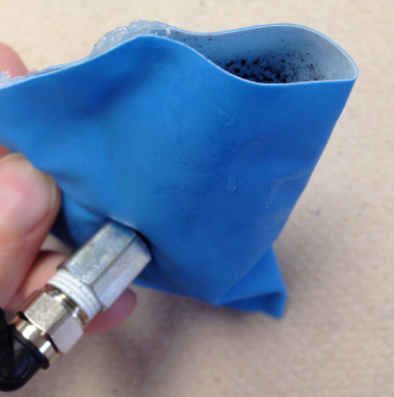 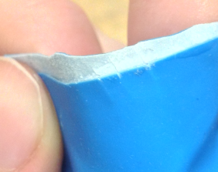

Figure 11: Granular jamming pad being assembled (left) and cracking of regular super glue (right)

Previous research showed that to ensure the grip of the granular jamming pad, the object size must not be bigger that 75% of gripper radius. The palm of the designed hand is a trapezoidal shape with a surface area of about 55 cm2. This should, in theory, allow it to pick up a wide array of objects. Practical testing showed, however, that depth of a granular jamming pad is actually far more important than the cross sectional area. The designed pad had limited depth, since it was made by gluing two flat objects together. A balloon, for example, had much better depth but did not utilize the available area on the palm. However, it was incredibly difficult to make a deeper pad out of the glove material because it necessitated adding “panels” of material. Each of these panels would have to be glued and cured over the course of days before another panel could be added. Additionally each of the interface points would be filled with glue and quite stiff, making it extremely hard for the paneled pad design to wrap around objects. One other unforeseen issue with the glove-based granular jamming pad was that the glove material was fairly thick and did not mold as well around objects as other, more flexible materials.

Granular jamming tests with a balloon did show promise, however, so the solution may be to revisit how a layperson could make a flexible, airtight, pad rather than giving up on granular jamming altogether. Finding a way to make a deeper and more flexible pad, or even just using a balloon, would still add a lot of functionality to the hand. This however would be something for future users to consider.

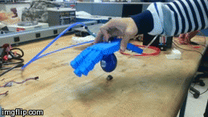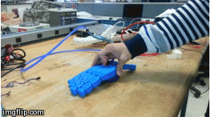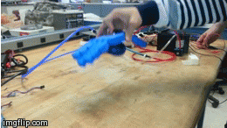

Figure 12: Stills from successful balloon granular jamming test.

## Electronics and Programming

Control of the hand is performed via an Arduino Uno microcontroller board to which all other components are connected. This microcontroller is in command of the hand’s two main subsystems: the fingers and the granular jamming pad. Below is a schematic of the electronics:

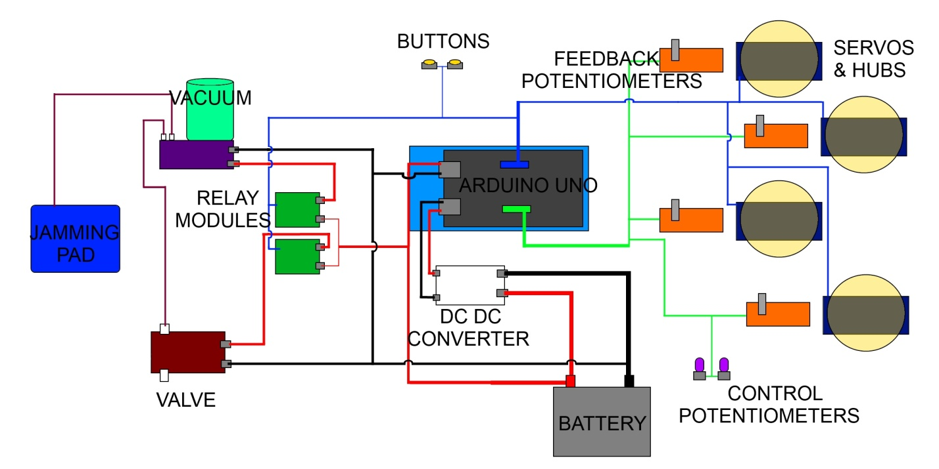

**Figure 13: Electronics Schematic**

In order to move the fingers, a strand of fishing line is attached to each fingertip, running down the hand and forearm and connecting to a linear potentiometer and then a servo. As the servo rotates, the line is shortened, and it curls the fingers inward towards the palm of the hand. The linear potentiometer is attached to the line, and its position is updated as the line moves.



**Figure 14: Image of linear potentiometer and motor setup.**

This information can be used as feedback to help tell the microcontroller at which position the servo actually is, and whether or not the servo should stop moving. In the team’s setup of the device, it used rotary potentiometers as an input to tell the servos when and where to move. This however is not the only way to send commands to the microcontroller, and was chosen as a method of control so that the team could effectively write a relatively simple demo program to simulate hand motion. The team was also able to send commands from a PC via a USB cable, and created a GUI for this application.

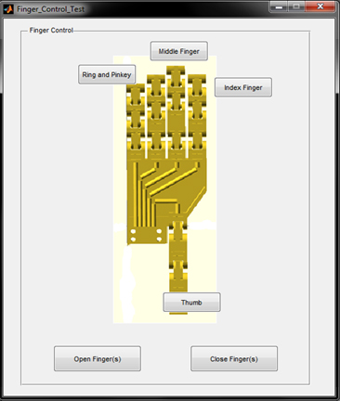

**Figure 15: Hand motion GUI**

Another method of control that is more conducive to prosthetic use is a myoelectric input from electrodes placed on the user. It should be possible to interpret these signals and convert them to commands the microcontroller understands. Getting support for a myoelectric input would be a very interesting future application of the hand.

The linear potentiometers are in place in order to allow the fingers to grip the contour of objects with slanted or curved surfaces, like an ice cream cone. The way the program is designed to work is that the user will tell the fingers to close around the cone. The program will break down the command into many small steps. For each step, the servo will move a fraction of the distance required to close. After moving a small distance, the microcontroller checks to see if the linear potentiometer has moved position. If it has updated position, the finger is not in contact with an object. Upon contacting an object, the finger will stop moving and the linear potentiometer will register the lack of motion. In the case that the potentiometer position was not changed, the program assumes that the finger is in contact with something, and the microcontroller will not send any more close signals to that finger. That way it can still send close commands to the other fingers until they too have come into contact with the item.

In order to control the jamming pad, there are two pieces of hardware that need to be actuated, the vacuum and the solenoid valve. Each of these two items is attached to a relay module. The relay module is a switch that can be turned on or off via a command from the microcontroller. This way the two items can be easily toggled between on and off states. However, while the relay module receives commands from the microcontroller, its power is supplied directly from the battery. This is beneficial because the vacuum and solenoid valve require double the voltage of the servos. Use of the relay module allows the board and servos to exist in a 6 volt circuit while also providing 12 volts to the solenoid and pump, protects the servos from burnout. For the purpose of the demo program, the two relay modules are controlled via pushbuttons.

# Prototype Fabrication

The main objective for the group was to keep fabrication of the project as simple as possible. This was a project that we wanted an individual with no 3D printing or assembly experience to be able to make themselves. This called for a simplified building process. From the control of the forearm, to the tools used for assembly, to the wiring and building, the whole design is based around simplicity. The only possible difficulty for a user would be getting access to a 3D printer.

All 3D printed parts have been put on github for easy and free access, along with assembly instructions. There are four small mounts for the motors and potentiometers, which slide into the forearm slots and are then secured with nuts and bolts. The motors themselves are secured into the mounts using the motor screws that they come packaged with. Forearm sections are bolted together with two nut/bolt sets. The hand and forearm screw together at the wrist with four plastic screws. Four servo hubs have to be screwed to the top of the servo motors. Servo hub teeth are made using ABS cement in a fairly simple process (discussed more in-depth in the “servo hub design” section of the report). Each half of the forearm has four bolts holes to attach it to the other half of the forearm case. Any of these forearm connections (connecting forearm pieces to make a half, or halves to make a whole) can be augmented with ABS cement to form a permanent, chemical weld. The hand itself prints as one completed piece, and the only assembly work required is to run fishing line through the fingers and palm of the hand, secure the rubber bands (one per joint—optionally two can be added to the base joint to overcome friction), and optionally, add set screws. The fishing line runs from the hand through the holes in the potentiometer mounts and then around the servo motor hubs, allowing the wire to bend the fingers. In total, 16 motor screws, 4 motor hub bolts, 8 nut/bolt sets, 4 plastic screws (or alternately 4 more nut/bolt sets), 15 set screws, 20 rubber bands, a few feet of fishing line, and one jar of ABS cement are required for construction of the hand and forearm. This is a very straightforward assembly with very few fittings required.

The granular jamming pad is also simple to make, using either balloons or rubber gloves. The gloves need to be cut apart then glued back together, sealing any air leaks, and then filled with ground coffee The tubing connects through the back of the palm to the pump, allowing the pump to pull air out of the palm and add it back in (through pump exhaust). The Arduino connects to the two digital push buttons and two rotational sensors used to control the hand for the demo program, and controls the vacuum and servo motors. Between the Arduino and the battery the wiring connects to a DC/DC converter, which steps down the voltage to accommodate the Arduino and the servo motors. Two relay modules connect between the valve and vacuum.

The assembly is simple, requiring very few tools; screwdrivers, silicone glue, an Allan key set, twist ties, and the ABS cement. Often the team would use electrical tape to keep the wiring grouped together and sorted as well. Assembly of the prototype, despite some minor issues, went very smoothly. The problems encountered and their solutions were as follows:

The linear potentiometers added extra friction to the system, causing the fingers to occasionally get stuck in a half-curled resting position. This was remedied by adding an extra set of rubber bands to the rubber band guides at the base of the fingers.

Additionally, one of the set screws was over-tightened, causing a hairline crack in a finger. In the future it is recommended that users put a drop of ABS cement in the set screws holes prior to set screw insertion to avoid this. Doing so will bond the layers of plastic together and make it less likely for the plastic to crack along a layer interface, as happened to the team.

The servo mount screw holes did not line up exactly with the screw holes on the servo itself. This was remedied by fixing the model for future users, but was left as-is in the prototype (in order to not waste school printer time). The prototype also bows slightly when under the full force of the servos, so the model was strengthened as well.

The printer malfunctioned while manufacturing the forearm and did not print the hand mount. This was remedied by printing a standalone hand mount and then using ABS cement to permanently bond it to the arm.

The motor hubs were also made slightly too tall, so they were ground down for use in the prototype and the model was repaired for future users.

These issues actually encompassed all of the assembly problems encountered, which, for a first prototype, is very few. The fact that there were so few issues and that they were so simple to solve just goes to show how straightforward assembly is.

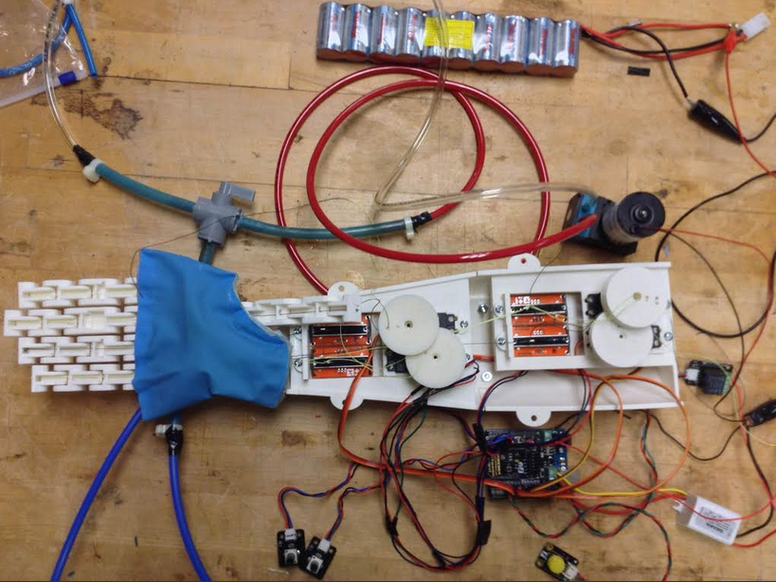

**Figure 16: Fully fabricated hand, lower forearm half, and granular jamming pad.**

# Performance Testing

In order to determine usability of the hand, it was necessary to actually test the performance of its components, both individually and in tandem with the rest of the parts of the hand and forearm. Performance testing of the device included tests of finger range, hand strength, demo control, and efficacy of the granular jamming pad.

In order to test finger range, the entire device, sans the granular jamming subsystem, was assembled. The fingers were attached to each respective servo and linear potentiometer and the proper hub was attached to each servo. The servos were rotated to create the largest linear displacement of the fishing line possible. For this test, the team saw that the fingers did not quite reach the desired angular displacement of 90o at every joint. This was due to the linear potentiometers limiting the range of motion, due to the fact that they were slightly shorter than the length of fishing line needed to fully actuate a finger. Despite this, the range of motion of the fingers was still good, and capable of grasping many common household objects. Another problem that the linear potentiometers created was that they provided enough resistance such that the rubber bands, which pulled the finger back into rest position, were unable to overcome that force. The team tried doubling up the rubber bands per joint, which seemed to help. The group would like to use either different, longer potentiometers in a future iteration, or use a different method to get feedback data.

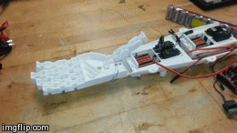 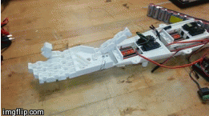 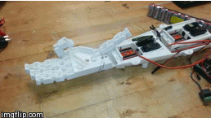

Figure 18: Stills from successful finger motion test.

Testing for the granular jamming pad was performed both with an assembled hand, and just with the pad itself. Testing originally started with a birthday balloon filled with coffee grounds. The balloon was attached to the vacuum and valve. The team then took the balloon and placed it over various objects placed on a flat surface. The vacuum was then turned on. With that shape, the balloon was capable of grasping and holding many small, light objects. The valve could then release the seal and returned the inside of the balloon to atmospheric pressure and the balloon released the object. The team then crafted its own pad, designed to better fit the palm. This pad was still able to grasp some objects, but not as many as the balloon. Looking at the pad, the team realized that it needed a different shape, more similar to that of the balloon. The pad needed to be thicker, so that it can more easily wrap around the object. Additionally the stiffness of the glove material made it more difficult for the granular jamming pad to wrap around an object. For a future design, the team would incorporate these findings into a new shape and material for the pad.



Figure 18: Stills from successful balloon granular jamming test.

Much of the hand control testing was done while waiting for the forearm to be printed and assembled (since much of the other testing required that everything be put together). For the hand control testing, a servo motor, a rotary potentiometer and a linear potentiometer were all attached to the Arduino. The rotary potentiometer was used to control the servo motor and the linear potentiometer was used to provide feedback. As the tester spun the rotary potentiometer, they would simultaneously slide the linear potentiometer. As long as they did both things, the motor would spin to the position commanded by the rotary potentiometer. When they stopped sliding the linear potentiometer, modelling contact with an object, the motor would stop spinning and instead hold its position. This testing was successful and showed that, once incorporated into the forearm, the potentiometers would correctly report contact.

Unfortunately, shortly after these initial tests (on April 30th), there was an accidental short circuit and the motor shield was damaged. The group must now wait on a new motor shield to arrive in the mail, as they are a fairly specialty item and are not sold locally (unlike the Arduino, which was also shorted and has since been replaced). As a result this has put a halt to further testing beyond these initial motion, control, and granular jamming tests.

The next thing that the team would want to test, however, is finger strength. For this the team would need to have the device assembled. The hand would be placed next to or on top of the object to be grasped. The fingers would then be moved to grasp the object and the object would be lifted. Objects of increasing size and weight would be lifted until the fingers could not maintain grip while attempting to lift the object. This testing was unable to be completed in time for this report due to an accident causing a few electronic components being shorted and burnt out. This should be a simple test to perform. However, based on the strength of the high torque servos, the hand should not have trouble picking up many household objects, up to the weight of roughly 7 pounds.

One more very important test would be a test of the finger dexterity. For this test, an oddly shaped object, such as an ice cream cone shape, would be placed in the hand, and the fingers would be told to close. This test would be to see how well each finger can wrap around the object, or if the fingers would collide with the object near the finger base and not wrap correctly. This test would be a success if the hand could achieve a realistically human-looking grasp on the object, and if the grasp is not easily broken by attempting to pull the object out of the hand.

Another test that the team would want to perform is a test of the potentiometer sensitivity. It is important to know if the hand can make contact with something without crushing it. To perform this test, a somewhat fragile object, such as a plastic or Styrofoam cup, would be placed in the hand and the hand would be told to close. If the potentiometers can register contact without crushing the cup, the test would be considered a success.

Hopefully, some or all of these tests can be performed in time for the presentation, provided that the replacement servo shield arrives in time. If it does not, the hand does show a great deal of potential and maybe these tests can be continued at a later date.

# Potential Improvements

There are a great number of very interesting ways for the granular jamming hand project to move forward. Obviously due to time constraints not every facet of the project could be fully explored, but one interesting direction that it could have gone was to get Bluetooth control fully functional. Right now the hand includes a demo program showing motion, but if a future team could put together a GUI that can be controlled on a cell phone, selecting different types of grip, that would be an extremely interesting direction for the project to go (given that it is how current state-of-the-art prosthetics function).

Another interesting direction that could be further explored is designing a truly “open-source” forearm. The current forearm is designed in SolidWorks, so while the .stl files for the forearm can be made available for people to port into open source programs and edit, it would be very exciting to have fully editable files available to users. In order to do this the forearm would have to be redesigned in an open source modeling software, which due to time constraints, was not possible for this project. Another very interesting direction for forearm continuation is to get it printing well without support material, and in smaller pieces. While it’s possible to print the forearm on a pretty high-end hobby printer with support material, it was never tested on a mid-range or low-end printer without support material, so it would be interesting to see how the forearm would fare in that scenario. It would probably need a small amount of redesign to optimize it for that style of printing.

Another improvement that could be made is to make all of the control elements fit into the forearm more efficiently. While everything did fit inside the forearm, it could probably have been more compactly designed, allowing for a shorter forearm (so that users with longer stumps could use the arm more comfortably) or for more components to fit inside the forearm. Another element of actual use of the arm is getting it to fit the user. It would follow from the 3D printed arm to 3D print a socket matching the shape of a user’s specific stump, for comfortable fit. This is something that would also be very interesting for a future developer to consider.

One final element of design improvement is the granular jamming pad. It proved to be very difficult to design a pad that could be easily be made by a layperson out of a soft material. The pad developed by the team used latex kitchen gloves. This material proved slightly too rigid for a well-functioning granular jamming pad, and did not mold well around objects. Additionally it was too shallow to envelop objects well. An ideal granular jamming pad should be very soft and extend a large amount from the palm, like a bubble. The designed pad fit into the space available inside the palm but did not extend out as far as it should have. Placing a balloon in the center of the palm actually worked very well as a granular jamming pad but, being much narrower than the palm, did not utilize the available space very well. As a result the granular jamming pad would also be a very interesting candidate for a potential redesign.

# Panel Comments

**Phase 4**

The panel had a few comments after the group’s Phase 4 presentation. The comments included adding links to the Gantt chart, the need to fix the hyperflexion in the fingers, and the orientation of the thumb. The team made the simple fix to the Gantt chart by adding links between tasks, and had already begun redesigning the thumb to change the orientation to improve functionality. However, the hyperflexion posed somewhat of a challenge. The problem with hyperflexion was that it was creating a small amount static friction that the motors had to overcome before fingers would begin to move. This caused the fingers to snap forward in an unrealistic way, and also slightly increased motor torque required (though it was still well within the abilities of the motors regardless). To fix this, the team added holes for set screws in all of the joints. Once the set screws were inserted, the fingers no longer hyperflexed, and actually looked more human-like when moving.

**Phase 5**

After the group’s Phase 5 presentation, the panel had some comments for the team to work on. The panel asked why the team had not considered choosing a 3 point contact since moving the thumb to a non-anatomically correct position made it look non-human. This is actually something that the team had considered due to a previous comment and had previously taken under advisement, developing the thumb, index, and ring finger around the three point contact suggestion. The ring and pinky fingers are more auxiliary, being driven by a shared motor, and while they do help with stabilization of grip the hand is primarily designed around the use of the first three digits. The reasoning for not getting rid of the two extra digits was that even though the thumb is oriented differently to a human thumb, the hand still looks very human and this was an important aspect of the design. Many users of prosthetics actually abandon the prosthesis after some time because it is intimidating to others. This way the hand appeared more approachable and human, and less intimidating.

Another comment was asking if any material would be put on the fingers. The group performed tests applying a material with a high friction coefficient (more of the rubber glove material used for the granular jamming pad) and found that it did help with finger friction and grip. The layout of this finger pad design is provided in the github for potential users of the hand to apply themselves.

# Gantt Chart

# Budget

The team went into the project with a goal to spend less than 500 dollars and was easily able to achieve this. Of the 500 dollars available the group spent only $275.95. However this is almost 100 dollars cheaper than actual cost of hand manufacture for an end-user due to the availability of tools, spare parts, etc for Stevens students. Throughout the semester the group was able to gather certain parts from professors or experts that they had been in contact with. Most notably the group borrowed a pneumatic valve, normally costing $49.99. Also, some parts bought for the team budget (such as the ball valve) are not necessary for the actual model of the hand due to design changes. One additional note is that the air vacuum pump in the hand budget does not account for shipping and handling which added thirty dollars to the team budget.

## Team Budget

(Budget actually spent by team members)

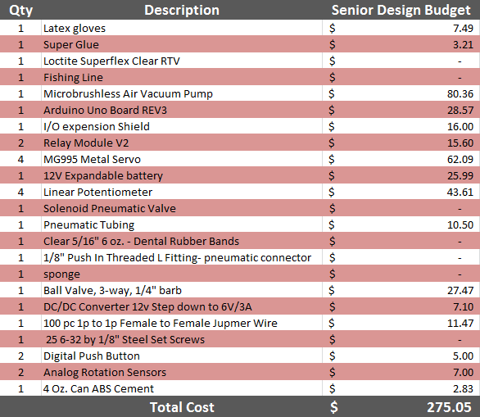

## Actual Budget

(Budget for manufacture by an end-user)

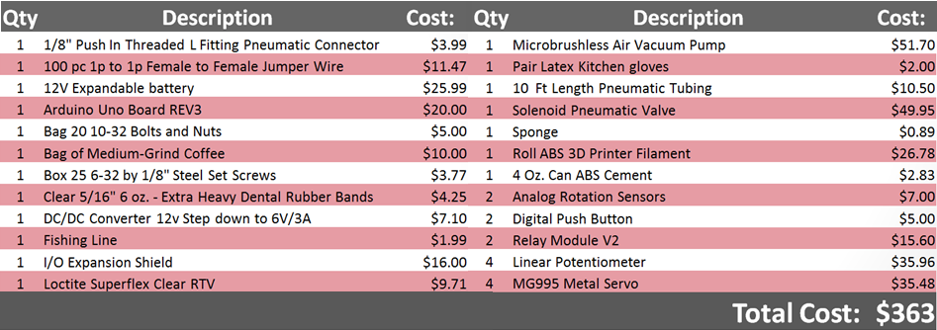

# Website

## Team Website

Granular3dhand.squarespace.com (“front end” website)

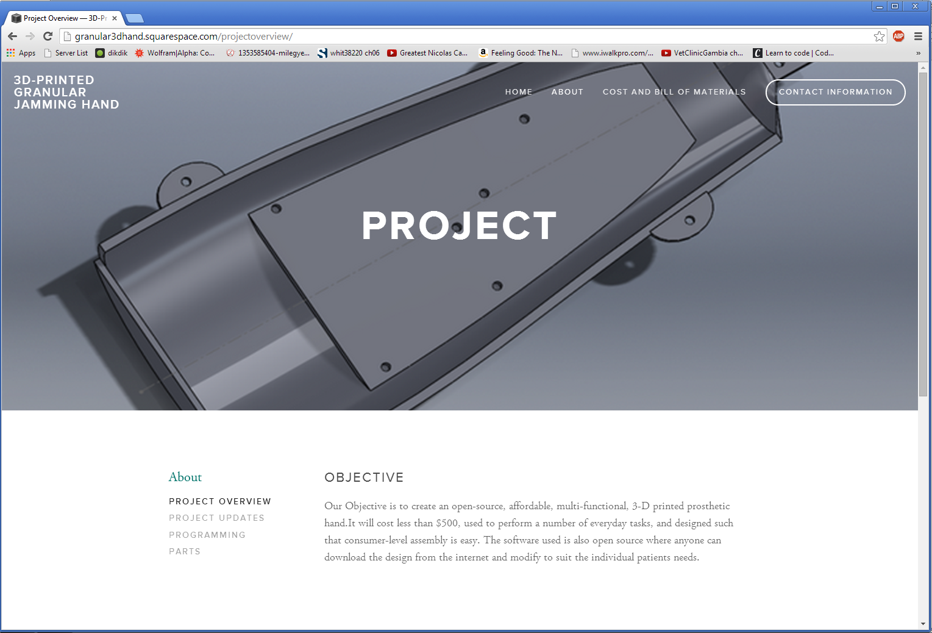

## Github Page

https://github.com/3D-Printed-Granular-Jamming-Hand/3d-printed-granular-jamming-hand

(Parts files, Arduino programs, assembly instructions etc are located here)

